Calix E7-2 and E7-20 GPON Data Only Programming (Remote Tech Assist)

Table of Contents

1.0 Overview 3
2.0 Effective Date 3
3.0 Related Documents/Links 3
4.0 E7-2 and E7-20 Standard FTTP HSI Activation GPON 4
4.1 Access 4
4.2 Calix CMS ONT ID Search 5
5.0 Provisioning Service 6
5.1 Provision Data Service using the Table tab. 6
5.2 Provision Data Service using the Form tab. 10
6.0 Deleting Service 11
6.1 Deleting Services using the Ports Tab 11
6.2 Deleting Services using Form Tab 13
7.0 Create ONT ID 13
8.0 Calix CMS Replace or “Zero” ONT 15
8.1 Calix CMS “Zero” ONT 15
8.2 Calix CMS Replace 17
9.0 Calix CMS Global ONT/SmartNID Serial Number Search 18
10.0 844G Switching from RG to GE Programming 20
11.0 Firmware 26
12.0 Troubleshooting, Tips, and Known Issues 27
12.1 Calix C7 1G Service 27
12.2 Identify missing ONT ID 29
12.3 Create ONT Profile 30
12.4 Verify Light Levels 30
12.5 Resetting ONT/SmartNID 32
13.0 Document Management 33

Overview

Target Audience | Programming
Impact/Benefit | This document provides step by step instructions on how to program the Calix E7 and E7-20. Included are instructions for FTTP and data.
Reason for Change | Updated the Provision Data Service using the Form tab section and Provision Data Service using the Form tab section to include using @QF_HSI_Data.  Removed link to the Tabview document, the Calix E7-FTTP (Fiber) HSI & Voice document, the Fiber Voice Trouble document, and the List of Unique Processes for FTTP Service document per no longer used in Forged Fiber 37.  Added the link to the CALIX E7-2 and E7-20 GPON Data Only Programming (QF Tech Assist) document.  Added the Switching from RG to GE Programming section from the 844G Integrated ONT Provisioning - CALIX E7 (COR–TSC and QF Tech Assist) document, as that document is being archived per no longer needed.  Changed doc author from Joela Flaxa to Debra Rudrud.

Effective Date

Effective Date | Expiration Date
09/07/2012 | Until Further Notice

Related Documents/Links

Document Name
CALIX E7-2 and E7-20 GPON Data Only Programming (QF Tech Assist).docx
Visit the library to view all documents: https://centurylink.sharepoint.com/sites/NAOLibrary

E7-2 and E7-20 Standard FTTP HSI Activation GPON

Access
Step | Action
Go to the Calix_CMS application.
Or access the EMS using the IP address.
To locate the IP address, view the order in Optius, go tow the Programming work ticket to view the device IP address, or on the Ethernet tab, view the OED on the facilities locate the IP address of the CMS server for the OLT to manually program service.

Calix CMS ONT ID Search
Step | Action
There are three different methods to search for a subscriber’s service in CMS EMS.
- Search using the OLT: ONT
  - Example: GDISNENWOL3:1010103
- Search using DTN.
  - Example: 1501799580
- Use the navigation tree to search.
  - Select the appropriate region (state).
  - Drill down to the Calix OLTCLLI.
  - Highlight this value and open the device.
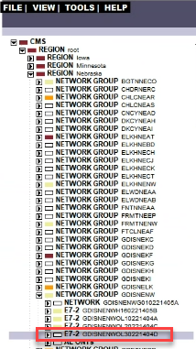

Provisioning Service

Provision Data Service using the Table tab.
Step | Action
- Select Create.
- Select Data Service.
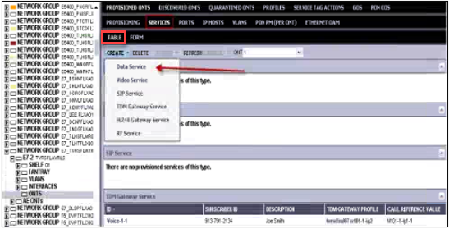
In the Create Data Service box, select options as follows:
- Subscriber Port: Select subscriber Ethernet port.
- Subscriber ID and Description: Enter phone number and customer name (if not defaulted).
- Service name: Select Data1 (if not defaulted).
- BW Profile: Select customer data speed profile (note: if a 1Gig/1Gig order and the tech states slow speed, check the BRAS.
Example: Redbacks must show 1,000,000KB not 100,000KB).
- Svc Tag Action: Select Tag action this will be CLLI Code-Data (if multiple VLANs choose –Data Vlan) If not seeing the above tag (example picture below) Choose either:
  - @QF_HSI_Data
    - Note: This is what Open Switchgate (OSG) uses in Forged Fiber 37
  - @HSI_Data
Example where the CLLI Code – Data did not exist, use alt @Enter S+C Vlan.
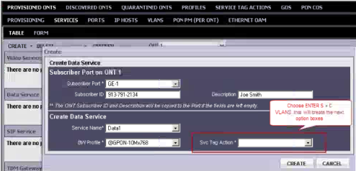
Either Svc Tag Action will then show the next entry boxes, inner and outer tags.
- Outer Tag: select Enter Value and enter the assigned S Tag/SVLAN/VPI value.
- Inner Tag: select Enter Value and enter the assigned C Tag/CVLAN/VCI value.
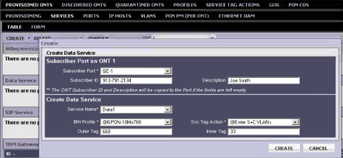
- Select Create to create Data Service.
Note: 1G Service requires the Speed set to AUTO under Provisioning.
- Go to Provisioning.
- Select AUTO for State (Mb/s) field.
- Select Apply.
Provisioned data customer
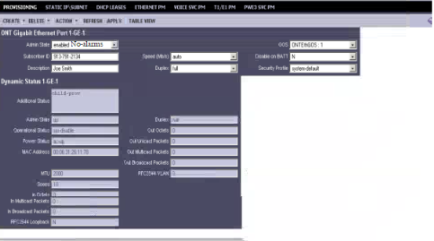
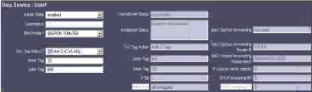

Provision Data Service using the Form tab.
Step | Action
Select Form in the Menu bar.
Populate the following field:
- Subscriber ID – enter DTN.
  - If the service is for a multi-port ONT, leave the top Subscriber ID field blank and only input the DTN under the assigned GE section.
  - If the service a single Ethernet port ONT, DTN needs input in both Subscriber ID fields.
- Description – enter the customer address.
- BW Profile – select the purchased speed.
- Service Tag Action – use the dropdown to select either:
  - @QF_HSI_Data
    - Note: This is what Open Switchgate (OSG) uses in Forged Fiber 37
  - @HSI_Data
- S-VLAN – enter the assigned S-VLAN
- C-VLAN – enter the assigned C-VLAN
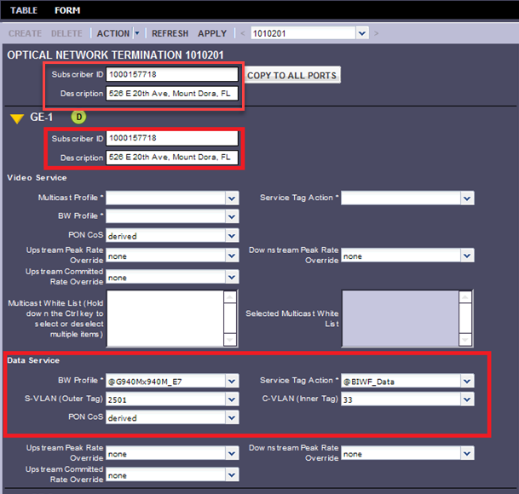
 | Select Apply to save.

Deleting Service

Deleting Services using the Ports Tab
Step | Action
- View the Provisioned ONTs service and select the service needed to delete.
- Select Delete.
- Select Data Service – the service is displayed.
- Select service needing to delete.
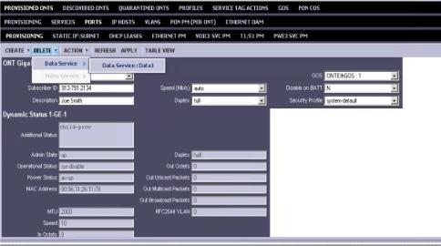
- A message box will appear asking to ensure agent is wanting to delete.
- Select Delete.
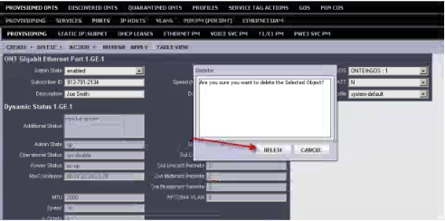
The service is deleted.
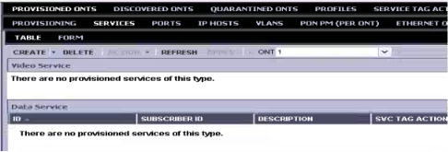
Repeat for all services on the ONT. This will leave the ONT as discovered and available for linking.

Deleting Services using Form Tab
Step | Action
 | Select Form in the Menu bar.
Identify the Ethernet port (GE-1, GE-2, GE-3, etc.) that require the removal of service.
- Ensure the correct service is being removed to prevent the removal of the wrong customer.
In the BW Profile field, select Remove Service.
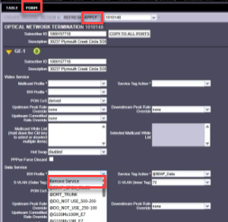
Select Apply.
Note: this only removes the programming from that Ethernet port.

Create ONT ID

Step | Action
Create ONT ID Using the CMS (applicable to GPON for E7-2 and E7-20).
Note: Check first if OSG created ONT. If not, use the following steps.
The RONTA number is used when creating the ONT ID.
- After selecting the correct OLT and the ONT option in the navigation tree, select Create.
The create ONT window will display.
- User Assigned ID – select Radio Button.
- ONT ID = shelf/slot/port/port/port/port/ont number. It is a 7-digit number-1010132, (shelf 01+slot 01+port 01+ont 32).
  - This is also the RONTA number excluding the 700.
- ONT PROFILE = if the ONT type is known, select the ONT type from the dropdown list. Use 762G if the ONT type is unknown.
- SERIAL# = leave blank.
Note: Once the ONT ID has been created, the field technician can scan the ONT/SmartNID to activate.
- REGISTRATION ID = entire full RONTA number (including the 700).
- Subscriber ID = leave blank
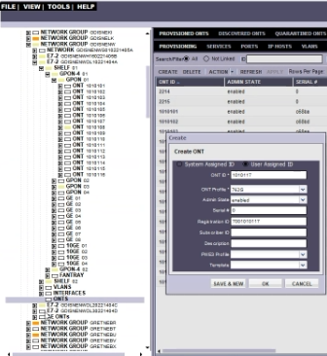
Select OK.
Note: if it is necessary to create more than one ONT, select Save & New.

Calix CMS Replace or “Zero” ONT

Calix CMS “Zero” ONT

Step | Action
In Calix CMS, navigate to the Provisioning tab of the ONT.
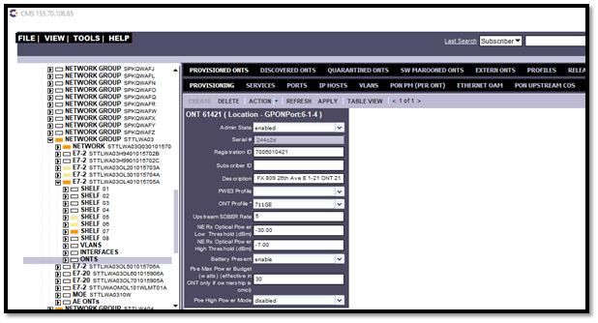
Select Action.
Select Replace.
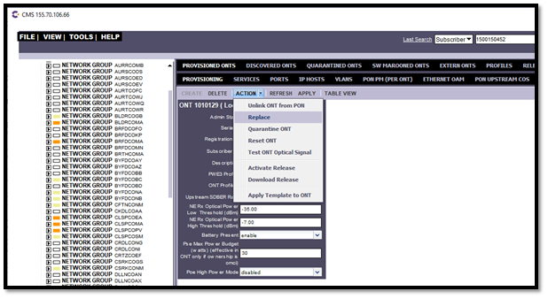
A box will display listing the current ONT Serial Number.
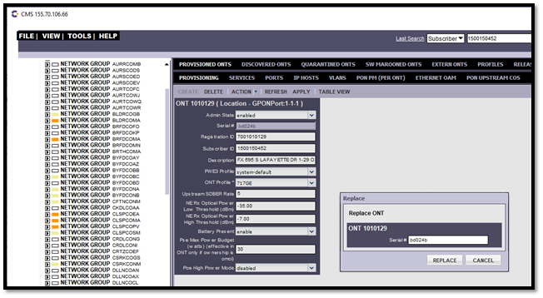
Over type the existing Serial # and replace it with a 0 (zero).
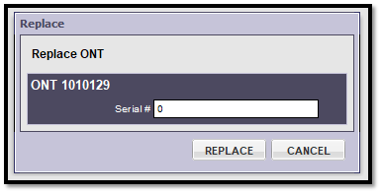
Then select Replace.
Agent will then see that the ONT is not linked and the Serial # is 0.
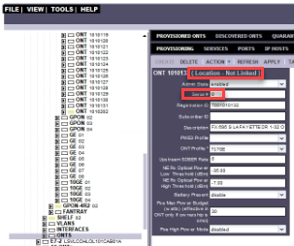

Calix CMS Replace
Step | Action
Replacing ONT Serial Number
This same process can be followed if replacing the ONT serial number for the field technician in the event the field technician is unable to use mobile app to complete the registration. Instead of typing 0, type in the ONT serial number from the tech.

Note: When typing the serial number, do not include the first four characters. Example, the serial number for a C5500 SmartNID is AXON10300DC6; type in 10300DC6.

Calix CMS Global ONT/SmartNID Serial Number Search
Step | Action
How to perform a global search using the ONT/SmartNID Serial Number.
- Select Tools, Search, Multi-Platform, ONTS (C7, E7, AE).
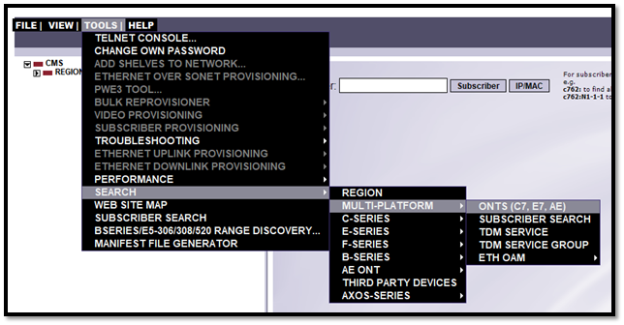
In the serial number field, select Contains from the drop down.
Next, enter the serial number of the ONT/SmartNID.
Note: leave off the first four charters. (Example, the serial number is CXNKBD024B; type in BD024B.)
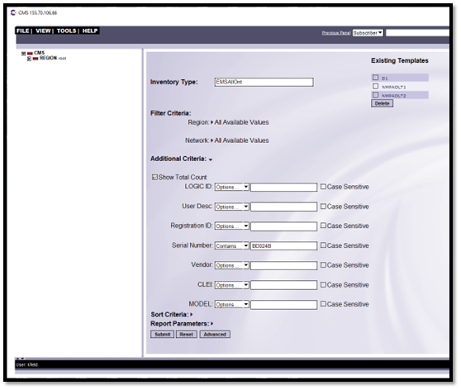
 | Select Submit.
- The next screen will display the results for the ONT global search.
- The search results will display the OLT, shelf, slot, and PON port, the ONT is physically connected to.
Note: compare the linked PON to the assigned facilities in Optius to determine if technician is connected to the correct PON port. If it is incorrect, the technician will need to move the customer at the FDH to the assigned facilities.
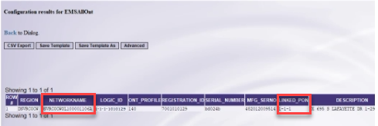

844G Switching from RG to GE Programming
Important: to maintain database integrity, it is necessary to follow the steps below. Do not delete the ONT ID.

Overview of Steps:
- Remove RG-1 Programming
- Change ONT Profile & Template to 700 or 803
- Re-program as GE Service

*See Switching from GE to RG Programming if agent is changing from 700 or 803 series to 844G

Step | Action
Remove RG programming. Under the RG port, change BW Profile to Remove Service and select Apply.
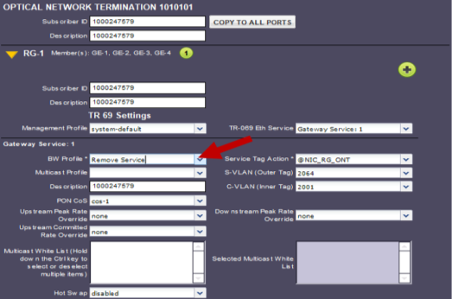
Select Provisioning (top menu).
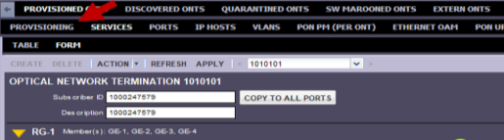
Change ONT settings to 700/803 series. Select Action (top menu) and Apply Template to ONT.
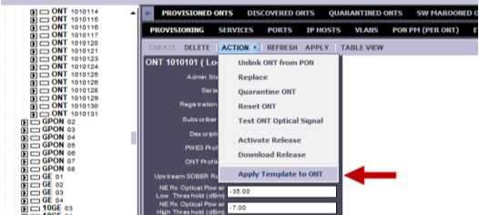
When the Apply Template box opens, select System-default and Apply Template.
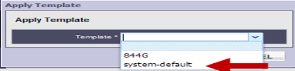
Note: We must take an extra step to clear RG from each GE port to completely remove the 844G/RG settings. Select Ports (top menu).
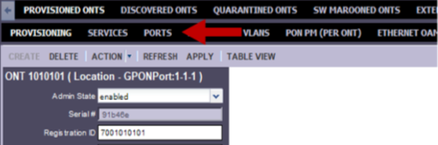
Select GE-1.
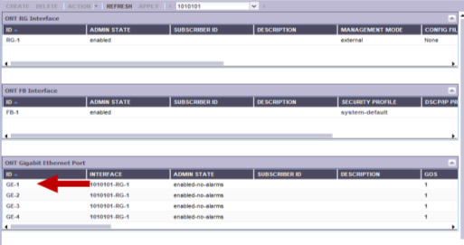
Change Interface from RG-1 to the blank option in the drop down and select Apply.
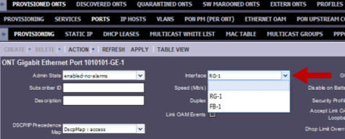
Important: must Repeat this step for each GE port on the ONT.
Tip: If the ONT is linked, the agent can highlight the GE ports under the ONT (left side) and select Provisioning (top menu) to adjust interface settings.
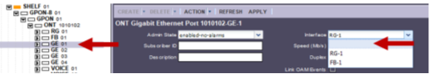
Select Provisioning (top menu).
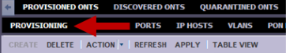
Change ONT Profile to match ONT model placed in field and then select Apply.
The example below is changing from 844G to 711GE.
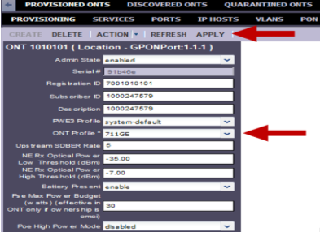
Reprogram as GE Service. Select Services (top menu).
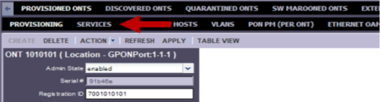
The agent will now see GE-1 instead of RG-1. Apply services as shown below.
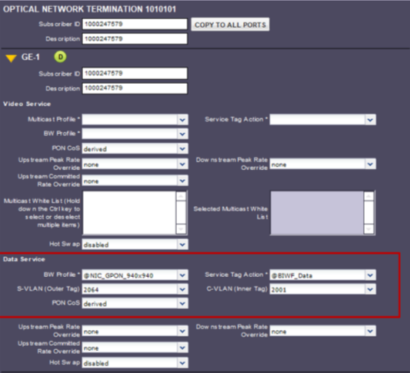
Data Service
Subscriber ID & Description = Customer DTN
BW Profile = @NIC_GPON_Speed
Service Tag Action = @QF_HSI_Data or @HSI_Data
S-VLAN = Assigned VPI
C-VLAN = Assigned VCI

Firmware
To view SmartNID Firmware:
- Search/Locate the Device CLL
- Locate the ONT
- Locate/View the PROVISIONING tab
- The SmartNID Firmware can be found in the Current Software Version field.

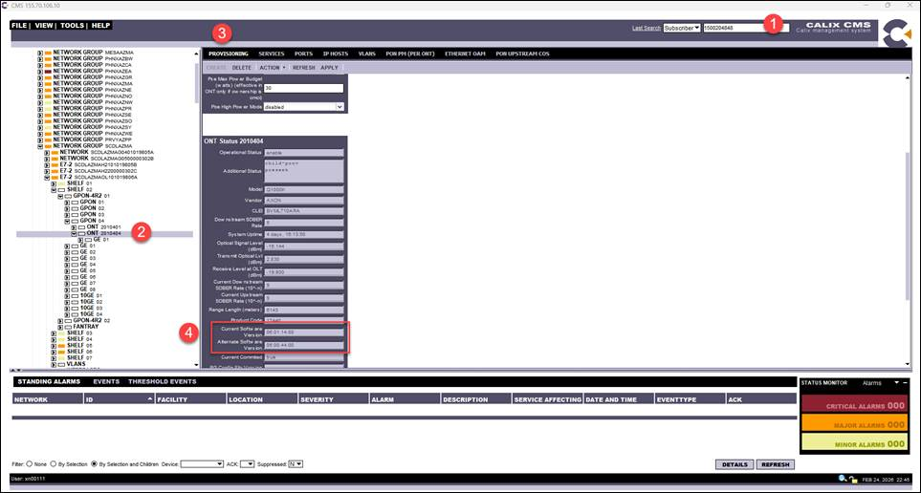

Troubleshooting, Tips, and Known Issues

Calix C7 1G Service
This section is specific to Calix C7 devices.

Step | Action
1G SERVICE MUST USE SPECIFIC ONTS
Scenario: Customer upgrades to 1G or orders 1G service and the field technician cannot sync.
- The ONT may not be capable of 1G.
- This can occur when a Calix C7 is cut to a Calix E7-2.
- C7 cannot support 1G so customers may have non-compatible ONTs.

Note: ONTs that are compatible with 1G service.
Calix ONTs: CenturyLink Lab Certified:
- 711GE 717GE 716GE-I 760G 760GX 762G 762GX
- 763GX 765G or G-R 766G 766GX or GX-R 767GX-R 803G
If the speed change only order received, and if the ONT Model shown in the CMS is not 1G capable, do the following:
- Advise STLD via e-mail that the order must be put on HOLD due to existing ONT cannot support 1G. Provide list below.
- STLD will create a Dispatch Fiber Work Required task in Ensemble stating the ONT needs to be changed to a 1G ONT at the premises.
- Order can be re-dated based on tech availability to install the new ONT.
- Field techs have been notified for 1G orders and may have to revise and place on hold if ONT not compatible.
 | If a tech is requesting 1G, validate the ONT model and advise technician existing ONT is not 1G capable and to follow field process for order revision for speed, place on hold, or install new ONT. Technicians can install the new ONT and link to provisioning by using the RONTA ID (aka Registration ID on ONT).
Degraded ONT Status (still works, does not cause issues but is visually misleading):
GPON
Response from Calix vendor: The degraded means it does not support as many ports as the Profile used.
- Not service effecting, just showing the ONT installed has less ports than the Profile, does NOT mean the service is degraded.
- NOT SERVICE EFFECTING but if the visual is bothersome, do the following:
  - Go to the ONT, view the ONT status. (This shows the ONT Model.)
  - Change the ONT Profile to match the Model.
  - Select Apply.
  - Status changes to Enabled.
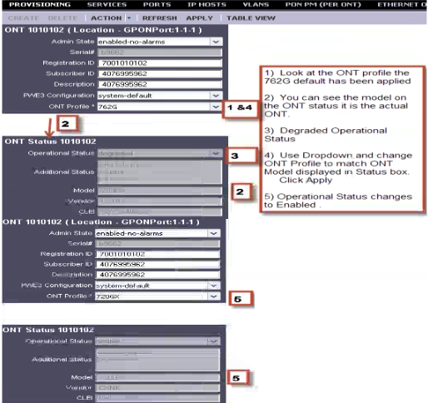
- Issue: GPON Ports are not enabled (active), either for a test order, or a service order.
  - Occasionally after a device is NOSA’d, the GPON ports may be disabled.
- If there is no ONT visible to the GPON (OLT) card, it will go to sleep.
- Ports must be enabled and awake to work test or service orders.
To enable (wake up) the ports, select the GPON port.
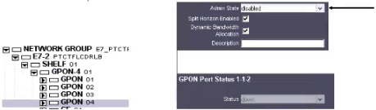
- If the GPON port is disabled, using the drop-down box, select the Admin State = disabled.
- Change Disabled to Enabled-no-alarms.
- Select Apply.
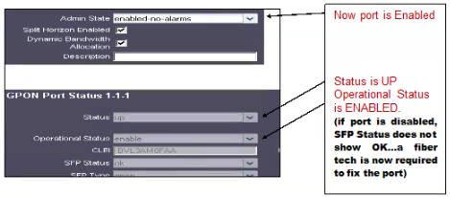
- Issue: NO LIGHT – When light is at the card in the OLT, but no light at the ONT: Cause is generally an incorrect or open fiber splice.
  - Refer tech to splicer or Field Supervisor.
- Issue: Speed Template not loaded for Speed Requested– Call NMC to open ticket to have NROC load profile- no tech online.

Identify missing ONT ID

Step | Action
How to identify if an ONT ID is not built.
In Poll DSLAM the ONT ID will be blank.
Note: follow Create ONT ID section to create an ONT.
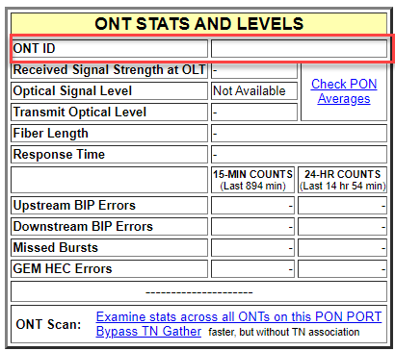

Create ONT Profile
Step | Action
 | In the scenario arises that requires the creation of an ONT profile, engage a center SME or Supervisor.

Verify Light Levels
Step | Action
 | Once the ONT/SmartNID has connected, verify light levels in CMS.
 | Select Provisioning on menu bar.
Scroll to ONT Status box.
- Verify the ONT is enabled and present.
- There are 2 different levels.
  - Optical Signal Level is the Transmit level, OLT to ONT.
  - Receive Level at OLT is the reverse, ONT to OLT.
- The levels should be between -8 (high) and -28 (low).
  - Levels outside of this range can be service affecting.
Note: In this example they are -14.0 and -16.6 and are considered good.
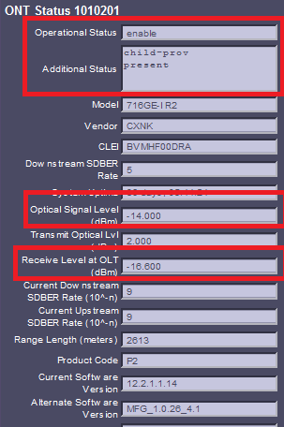

Resetting ONT/SmartNID
Step | Action
Select the ONT in the tree if necessary.
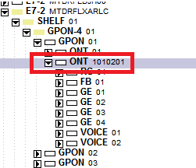
 | Select Provisioning in the Menu bar.
Select Action and then Reset ONT on the Menu.
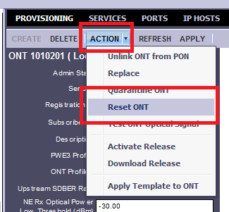
Select Reset ONT on the pop-up window.
- It is not necessary to check any of the options on this window.
- The ONT takes 1-2 minutes to complete the reset.
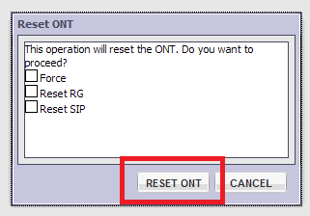
Note: Normally resetting the ONT is a last resort effort.
- If all other troubleshooting has been completed and there is still no traffic passing or the gateway has not pulled an IP, the reset may help.
- It is not possible to reset an ONT that is missing, the system will display a failure notice.
Note: Some CASA ONT’s require a reset to restore service.

Document Management

Document Management
AUTHORS
Author | SME |  | Name |  |  |  | Telephone Number | E-mail Address
X |  |  | Debra Rudrud |  |  |  | 214-617-2123 | Debra.Rudrud@ForgedFiber37.com
 | X |  | Angie Shoecraft |  |  |  | 817-330-5067 | Angela.M.Shoecraft@ForgedFiber37.com
REVISIONS
Date |  | Issue |  | Revised By |  | Comments
09/07/12 |  | 1 |  | Cathy Butler |  | Initial Version
05/23/13 |  | 2 |  | Cathy Butler |  | Added RONTA information
11/14/13 |  | 3 |  | Cathy Butler |  | Changed from Default ONT to 762G profile to sync with OSG. 762G is NOT the field ONT but only used for Ronta. Real ONT type updates when tech completes Ronta. Added note, no Ronta on Bpon.
12/04/13 |  | 4 |  | Cathy Butler |  | Changed the BW profile for Prism to GPON-Video_0x1G instead of using 100mx10m
12/19/13 |  | 5 |  | Cathy Butler |  | Added Suspend/Restore
02/06/14 |  | 6 |  | Cathy Butler |  | Added Tips/Troubleshooting
10/09/14 |  | 7 |  | Cathy Butler |  | Revised suspend service, vacation or full, to only disable the services on the ONT, not the entire ONT.
11/13/14 |  | 8 |  | Cathy Butler |  | Separated FTTP from VDSL2. New MP #.
07/22/15 |  | 9 |  | Cathy Butler |  | Added E7-20 references, programs the same as the E7-2
03/21/25 |  | 10 |  | Joela Flaxa |  | Converted to current standards and template.
05/30/25 |  | 11 |  | Joela Flaxa |  | Updated to add information for CMS replace or “Zero” ONT, ONT search and create ONT ID. Updated Troubleshooting section to add Identifying missing ONT ID, Create ONT Profile, Verify Light Levels, Resetting ONT/SmartNID.
11/05/25 |  | 12 |  | Joela Flaxa |  | Updated title to remove COR-TSC.
02/06/26 |  | 13 |  | Debra Rudrud |  | Updated the Provision Data Service using the Form tab section and Provision Data Service using the Form tab section to include using @QF_HSI_Data.  Removed link to the Tabview document, the Calix E7-FTTP (Fiber) HSI & Voice document, the Fiber Voice Trouble document, and the List of Unique Processes for FTTP Service document per no longer used in Forged Fiber 37.  Added the link to the CALIX E7-2 and E7-20 GPON Data Only Programming (QF Tech Assist) document.  Added the Switching from RG to GE Programming section from the 844G Integrated ONT Provisioning - CALIX E7 (COR–TSC and QF Tech Assist) document, as that document is being archived per no longer needed.  Changed doc author from Joela Flaxa to Debra Rudrud.
02/25/26 |  | 14 |  | Debra Rudrud |  | Added the Firmware section.  Updated to NetworkCo Template.
APPROVAL
Name |  |  |  |  | Title |  |  |  | Date Approved
Brian Lunseth |  |  |  |  | Mgr. Program and Process Management |  |  |  | 09/05/2012
Liz Bordano |  |  |  |  | Manager – Mass Markets Ops Excellence |  |  |  | 03/21/2025

